QGIS DATA MANAGEMENT TUTORIAL

Task: We have been tasked by the Police Department to create a map showing the number of crimes (specifically burglaries) per census tract from 2000 till present. We have access to shapefiles containing our census tracts, all crimes points, and political boundaries.
1. Open QGIS
2. Use the Load Vector Button 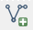 to load the following shapefiles.
Police_GDB_POLICEGISEDITOR_All_Crime.shp = Point data showing burglaries
COM_GDB_GISADMIN_COM_BaseMap_Demographics.shp = Census Tracts
COM_GDB_GISADMIN_COM_Political_CouncilDistricts.shp = City Council Districts
3. Push the CRS button in the bottom right corner to bring up Project Properties. Here set your CRS to EPSG:2915.
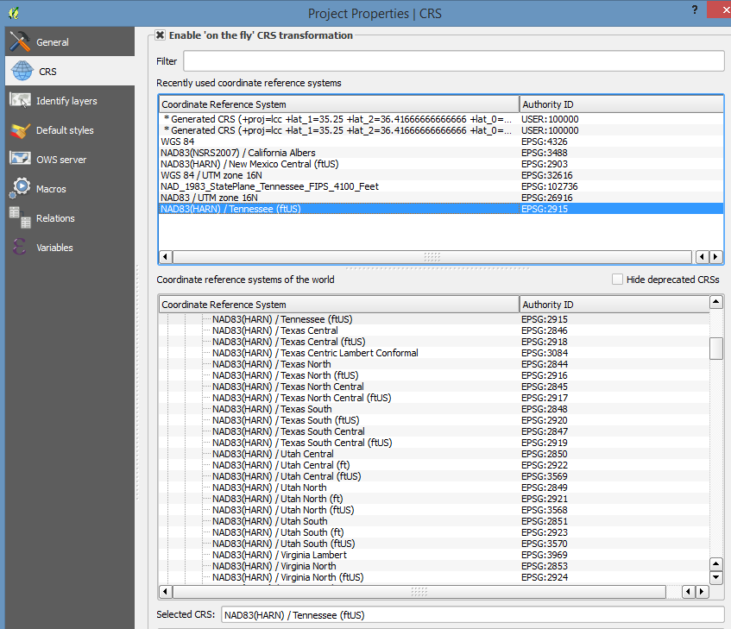

4. Your screen should now look similar to the one shown below. (Your colors may be different)
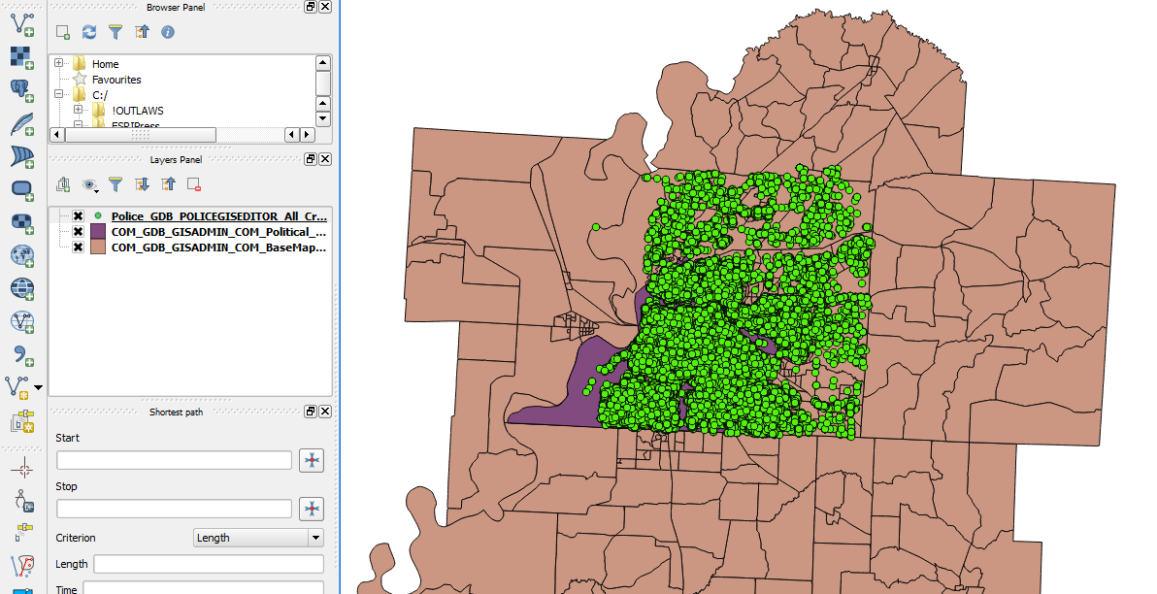
5. Open your Attribute Table for the Crime Point data by right clicking on the layer in the layers panel and selecting Open Attribute Table.
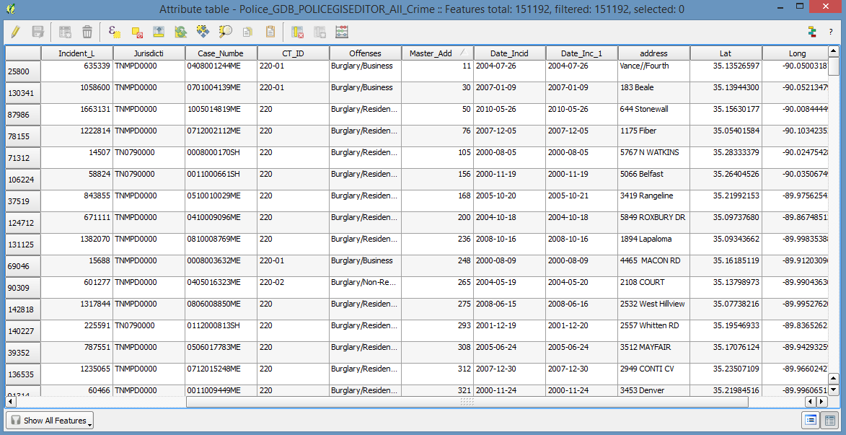
Notice the Field named Date_Incid, this is the date the Crime was reported. If we click on the Table Header (Date_Incid) we can sort these.
Q1: What is the date of the most recent incident?
6. Notice the incidents with dates of NULL and 1922-01-10 and all dates before 2000. We want to exclude these records. To do this we click on the 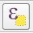 button to select features using an expression.
In the Expression Box enter this expression. "Date_Incid" > '2000-01-01' as shown below.
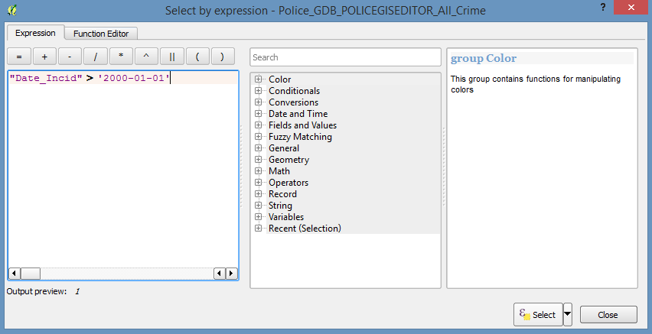
Make sure to put the table name "Date_Incid" inside double quotes and the table value '2000-01-01' into single quotes.
What would be the expression to select all dates between 01-01-2000 and 12-31-2007?
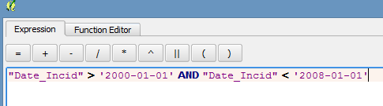
Q2: What would be the expression to select all dates before 01-01-2000 and after 01-01-2008?
Q3: What would be the expression to select all dates after 2000 and only Burglaries at a Business? (Hint: it would be the records with the "Burglary/Business" attribute in the Offenses column. )

7. We can verify our Selection Expression worked by looking at the map. The points that fit the selection criteria will now be highlighted a different color than the other points (below they are the points in yellow.) Additionally the attribute table will now have each record highlighted.
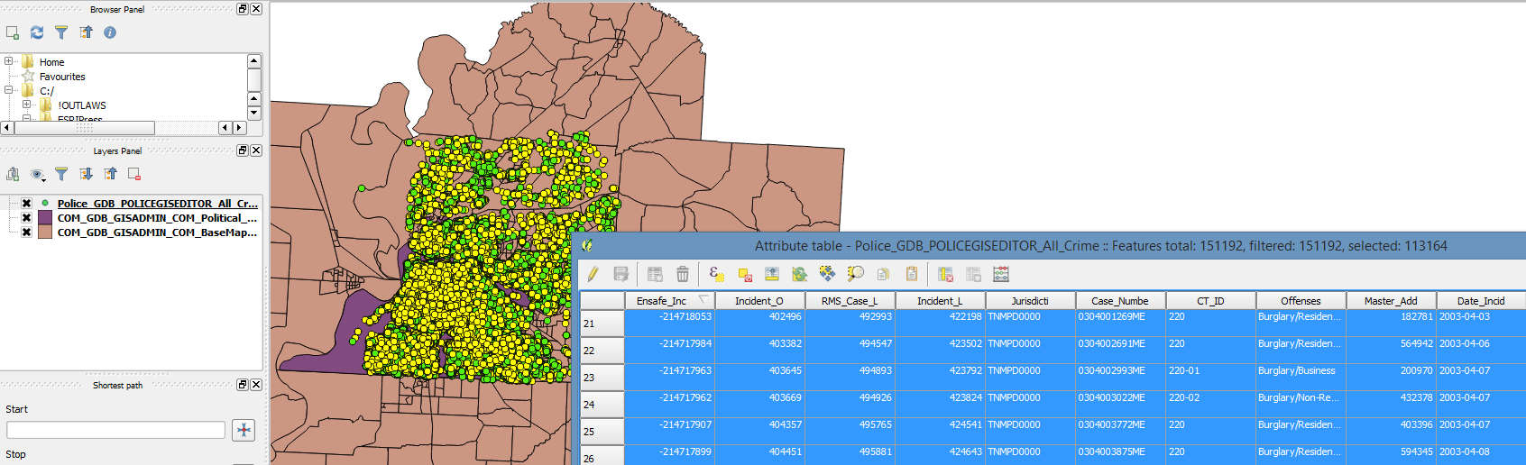
8. While selection is still active, right-click on the Crime layer and select Save As. When the Save Vector Layer as Menu appears, under Encoding be sure to select Save only Selected Features, then click browse (next to Save As) as browse to your work dir and save the new shapefile as newcrime. Also be sure to set your CRS to EPSG:2915.
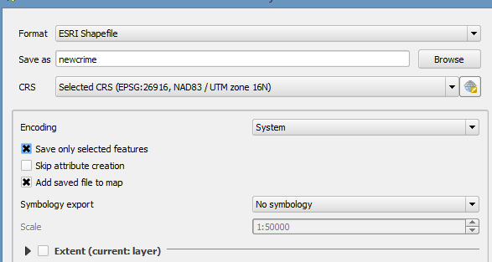
9. We now want to find out how many crimes have occured in each census tract from 2000 till present. To do this we need to right click Vector > Data Management Tools > Join Attributes by Location.
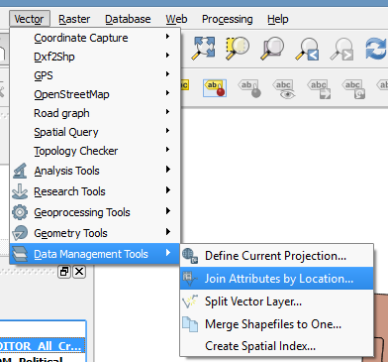
10. The Target vector layer is the one we want to add the attributes to. In our case, this will be the Demographic shapefile with Census Tracts. The Join vector layer will be the newly created newcrime.lyr. As we want to sum the total number of crimes per tract, select Take summary of intersecting features and choose Sum. Name the output file as join_output.shp. In the Output table select Keep all records.
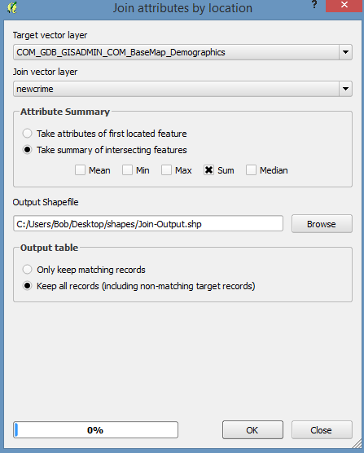
Q3: If we wanted to join the census tract id # to the crime point so that each crime point had an attribute showing which census tract it occurred in what would the Target Layer, Vector Layer, and Attribute Summary fields be?
11. QGIS will automatically add the newly joined layer to the layer menu. Your map should now look similar to this.
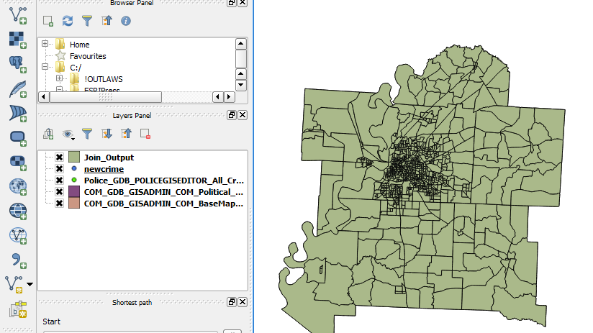
12. You can now open the attribute table of Join_Output (right click in the layer panel) and at the far right end of the table you will see a new field called Count. This contains your count of crimes per tract.
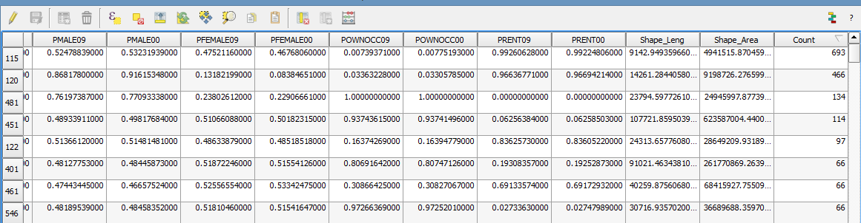
13. Since we are only interested in the Census Tracts that are within are City we will move the COM_GDB_GISADMIN_COM_Political_CouncilDistricts layer to the top of our Layer Panel.
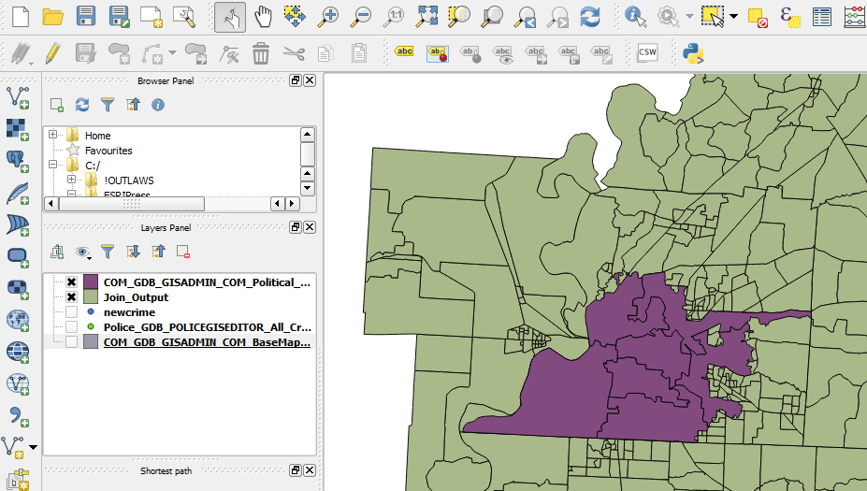
13. To isolate our target study area we need to clip the Join_Output layer to Political_CouncilDistricts layer. We do this by going to Vector > Geoprocessing Tools > Clip
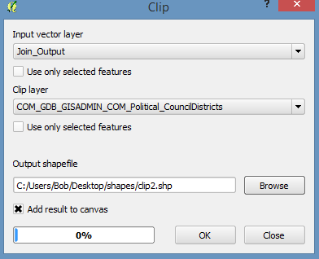
14. If we examine our clipped features we are now only looking at census tracts that occur within the boundaries of our city.
15. We now need to symbolize our map correctly. To do this right click on the clip.lyr in your layers panel and select properties (or just double click on the layer.) This will bring up the Layer Properties. Under the style tab select Graduated from the drop down menu.
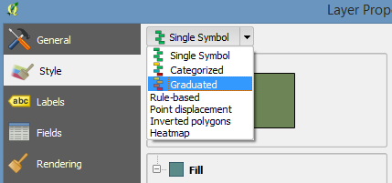
16. In the new menu, for the Colum select Count (the field created when we joined the crimes to the census tracts.) In classes hit the up arrow so you have 6 classes and hit OK.
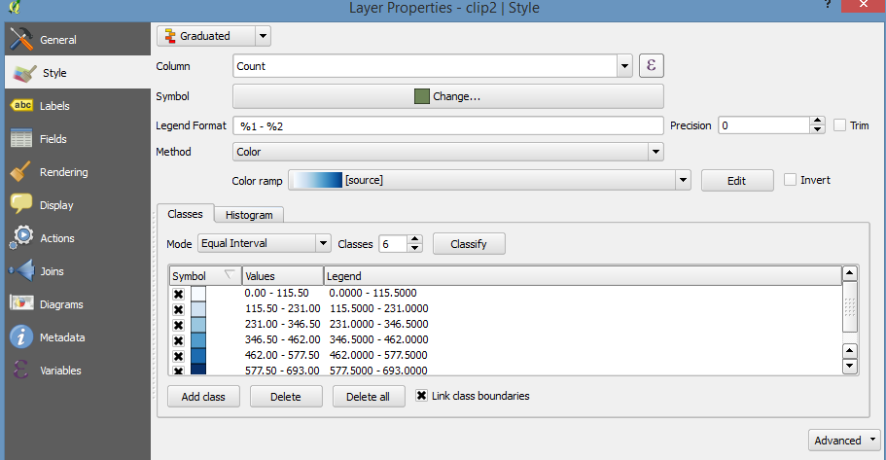
17. QGiS will now look similar to the graphic below. From this graphic we can see the majority of the census tracts fall in the first two catagories with only 3 districts really standing out.
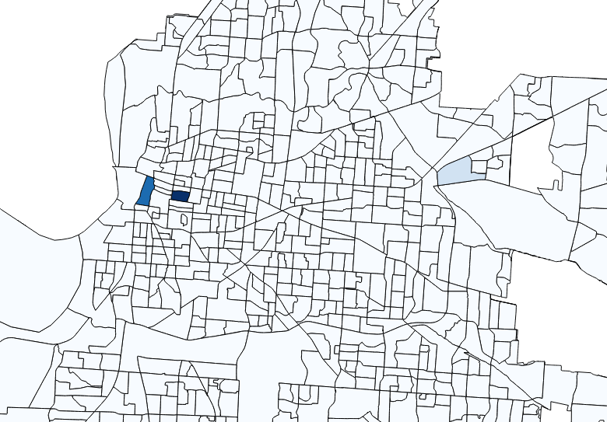
18. Let's see why this is. Go back to the layer properties > style > graduated and select the Histogram tab that is next to the Classes tab and hit Load.
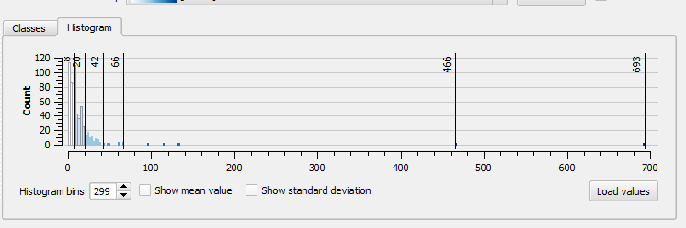We can see the vast majority of census tracts have less that 40 burglaries and only a few have more than 66 burglaries. To better represent the data we need to choose a different classification. now select Natural Breaks for the classification and hit OK.
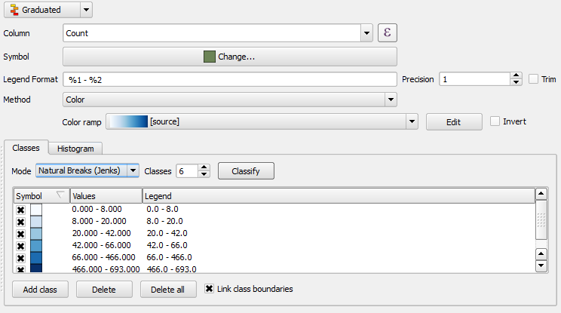
Your map should look similar to the one below.
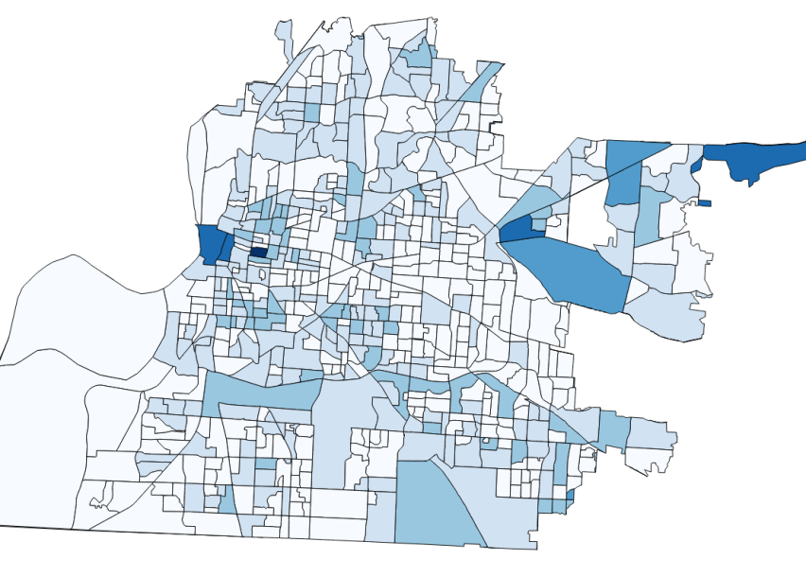
Q4: Repeat the last step using the different classification methods. Why is Equal Interval not appropriate for this data? What classification methods are appropriate and why?
Q5: Using Print Composer create a map with a legend and title.
Bonus Question: The Police would like a similar map, only this map will only show Residential Burglaries from 2005 till present. Analyze the data and create a visually appealing map.

